**Wellbeing Film Night**

**Wednesday 12th February**

3:25pm – 5:00pm

Children are invited to stay after school to watch an age appropriate film in a classroom.

£4 per child which includes: movie, drink & a hot dog

*(or dietary applicable alternative)*

**\*\*\*Booking open via School Spider app or if you log into the school website\*\*\***

**Booking strictly closes on Tuesday 11th February at 4pm - we CANNOT add any more on after this date/time.**

Reception film: **Zog/ Zog and the Flying Doctors (U**) 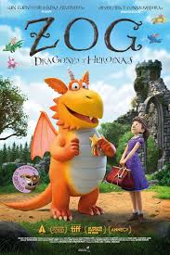 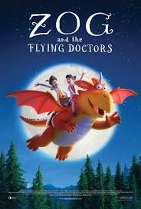

KS1 film: Inside Out(U) 

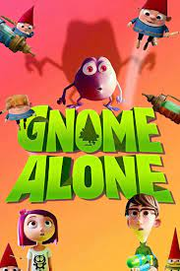

KS2 film: If (U)

**.**